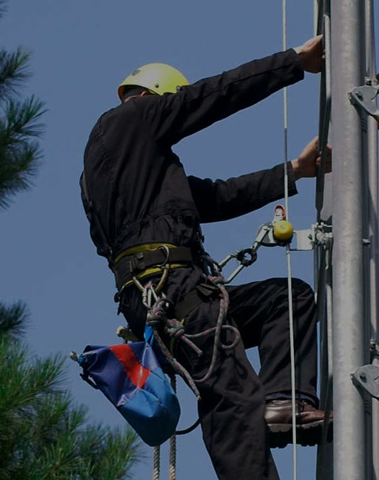

Fall Protection System

-By Aetna Enterprises India Pvt. Ltd.
TYPES OF FALL PROTECTION SYSTEM | #01
Types of Fall Protection System

At Aetna Enterprises India Pvt. Ltd., we provide an extensive range of fall protection solutions engineered for optimal safety and efficiency. Our offerings include:
Horizontal Lifeline Systems
Designed to protect individuals near the leading edge of a roof, these systems are engineered to minimize the force exerted on both the person and the anchor during a fall, ensuring a controlled and safe deceleration over a specified distance.
Vertical Lifeline Systems
These systems are ideal for individuals working on vertical ladders, such as chimney ladders, monkey ladders, and other vertical structures, offering reliable protection and secure anchorage.
Overhead Lifeline Systems
Tailored for use on elevated platforms such as dairy tankers, bulkers, oil tankers, railcars, or airplanes, these systems provide robust fall protection for workers operating at heights.
Crane Bay Horizontal Lifeline Systems
Specially designed for crane bay rails, which are often narrow, dust-covered walking surfaces, these systems significantly reduce the risk of slips, trips, and falls from heights.
Pipe Bridge Lifeline Systems
Pipe rack systems, with their extensive, elevated, and tiered walking surfaces, are best safeguarded by our horizontal lifeline systems, ensuring comprehensive protection over long distances.
Skylight Fall Protection Systems
Our Skylight Protectors are specifically engineered to prevent falls through roof lights, offering a reliable safety solution for workers operating near skylights.

ROOFTOP OR HORIZONTAL LIFELINE SYSTEM | #02
Rooftop or Horizontal Lifeline System

Horizontal Lifeline Systems serve as your essential line of fall protection, offering both active and restraint options. These systems are designed to either arrest a worker in the event of a fall (active system) or prevent workers from reaching fall hazards (restraint system).
Rooftop Lifeline Systems
Ideal for roof work areas that lack existing anchor points, our rooftop horizontal lifelines provide a comprehensive fall protection solution. A rooftop horizontal lifeline typically comprises a cable attached to two or more anchor points on a roof, effectively mitigating fall risks.
Custom Design and Installation
Our team of safety specialists collaborates with clients to design, fabricate, and install permanent rooftop horizontal lifeline systems suitable for both flat and sloped roofs. Each system is meticulously crafted to meet the specific requirements of the work environment, ensuring maximum safety and efficiency.
Materials and Certification
Constructed from high-quality stainless steel, our rooftop lifelines are durable and reliable. We offer a variety of connection posts tailored for different types of roof sheets. Our systems are certified to EN 795:2012 Type C and CEN/TS 16415:2013 standards, ensuring compliance with stringent safety regulations.

LIST OF ROOF TOP OR HORIZONTAL LIFELINE COMPONENT | #03
List of Roof Top or Horizontal Lifeline Components

01. Trapezoidal Sheet Post Standing Seam Post
02. Trapezoidal Purlin Post
03. Fragile Sheet Post
04. Monitor Roof Post
05. Flat Post
06. Shock Absorber
07. Tensioner (Lock Pin)
08. Tensioner (Swaged)
09. Tensioner (Swage-less)
10. Wire Rope
11. Wire Rope Cap
12. Intermediate (Fixed)
13. Intermediate (Swivel)
14. Cable Extremity (U Bolt/Thimble)
15. Cable Extremity (Swaged)
16. Cable Extremity (Swage-less)
17. CORNER BRACKET
18. STANDING SEAM CLAMPS
19. KLIP LOCK CLAMP
20. KALZIP CLAMP
21. STRIPS (For Clamps)
22. 1 BOLT
23. INSPECTION TAG
24. Glider RUNNER
25. KARABINER
26. Work RESTRAINT LANYARD
27. Rivets And Screws.

TYPES OF FALL PROTECTION SYSTEM | #04

Contact Us


Head Office:  Plot No. Aa-15 , 1st Floor, Hargovind Vihar Vijay Vihar Phase 2, Rohini,Sector-4, North West Delhi North Delhi Dl 110085 In | Branch office:  Flat No-1702, Tower-E Ajnara LE Garden Sector-16B Near EK Murti Chock, Roza Goal Chakar Nodia, Greater Nodia(West). |   Support:    Email: sales@aetna-india.in    Call: +91 8130698981    Web: aetna-india.in

